- Add Branch Inquiry searching in Customer Order (IntegSys)

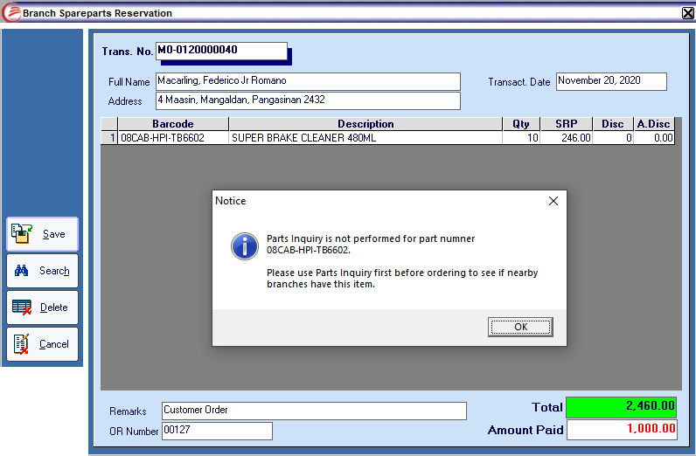
Customer orders will require a Parts Inquiry before the branches can save the reservation order. This validation will require the branches to perform Parts Inquiry first to see if the ordered part number has existing inventory to nearby branches and just request the part on them rather than ordering it on our warehouse.

- SP POS like entry (spWIMS)

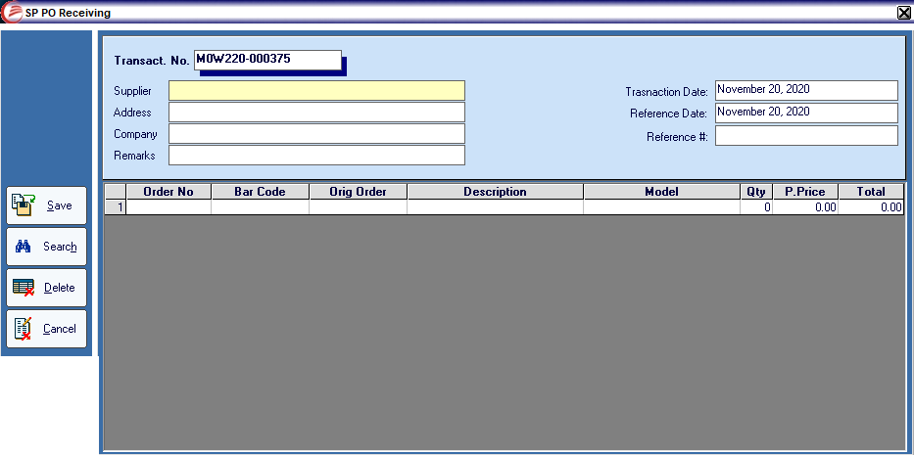
SP PO Receiving – old form

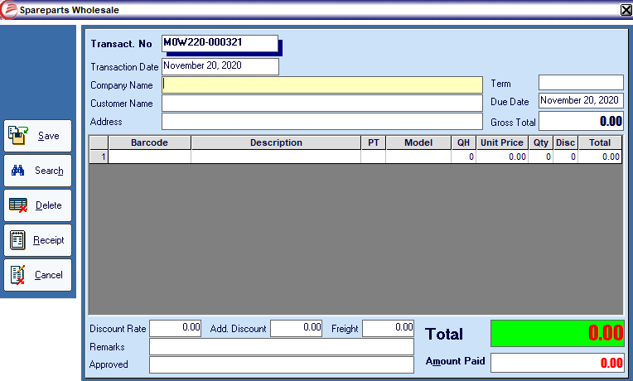
SP Whole Sale – old form

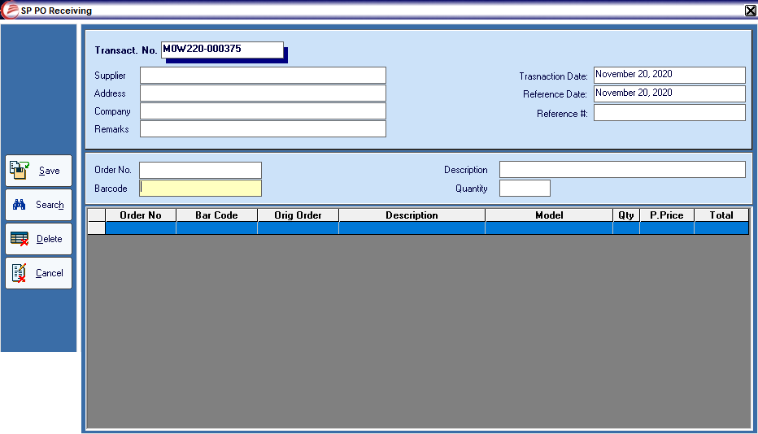
SP PO Receiving – new form

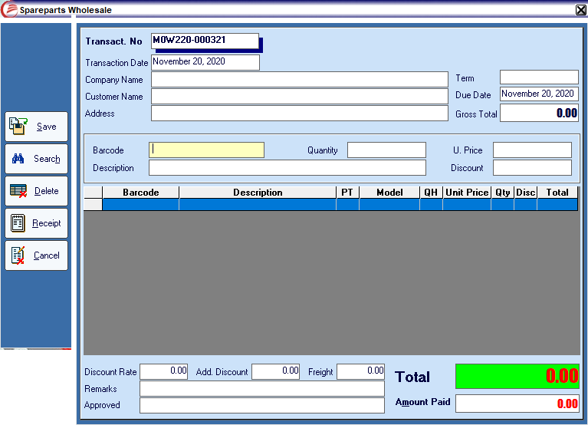
SP Whole Sale – new form
SP transactions encoding are adjusted into POS like encoding wherein the system has now the capability of adding one quantity of a new item or previously punched item using barcode reader. If a barcode reader is not present the encoder can still change the quantity value. This may speed up the receiving or issuance of parts since the warehouse will not have to count the items first then encode, they can now scan the item and let the system auto count.

- Facebook Like Raffle Promo

Guanzon Group will have a raffle promo wherein clients that transacts to us will earn raffle entries when they LIKED our Facebook page. All transaction with receipts/invoices will have a webpage link and will be sent to the customer’s mobile number.

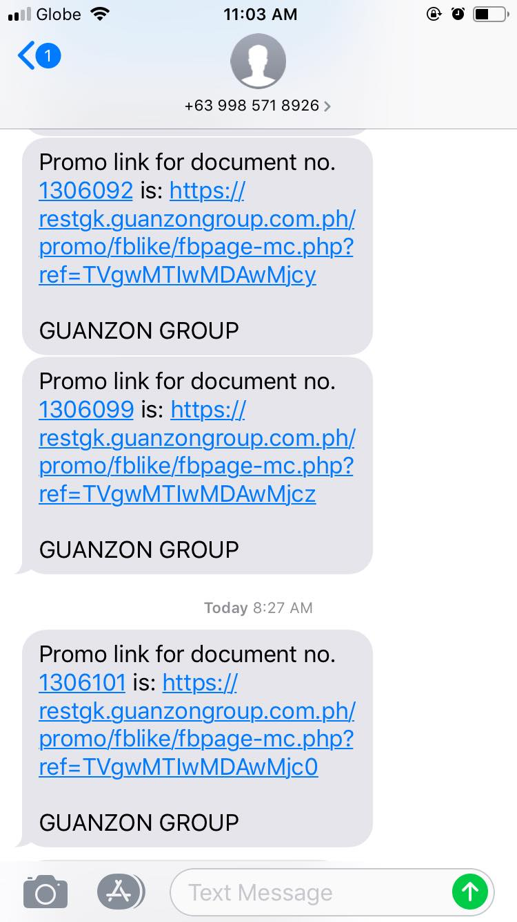

SMS Received by the customer
An auto encoder will be installed to the branch’s PCs to auto send the transaction info to our main server, the branch/client shall only wait 1-5 minutes to receive the promo link. If the promo link is not received within 5 minutes they can try to call MIS to check if there is a problem with the utility, or just encode the transaction info to the manual encoding application. The information must be correct and mobile number must be active.

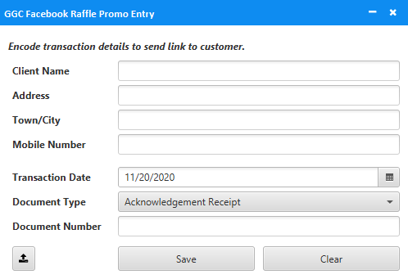
Raffle Entry Encode (Manual)

When the customer pressed the link sent to him. He will be redirected to a page that will require Facebook login. After the login he will be redirected to the company to like page. He will just have to click the button, click LIKE and SUBMIT button to earn one raffle ticket. Upon following the page, the customer will now receive a text message informing him that he earned one raffle entry for following our page.
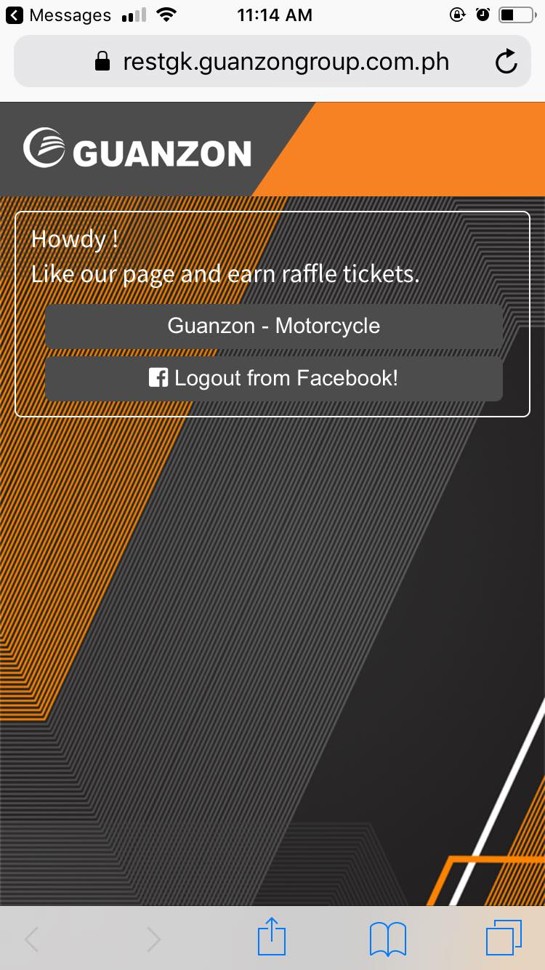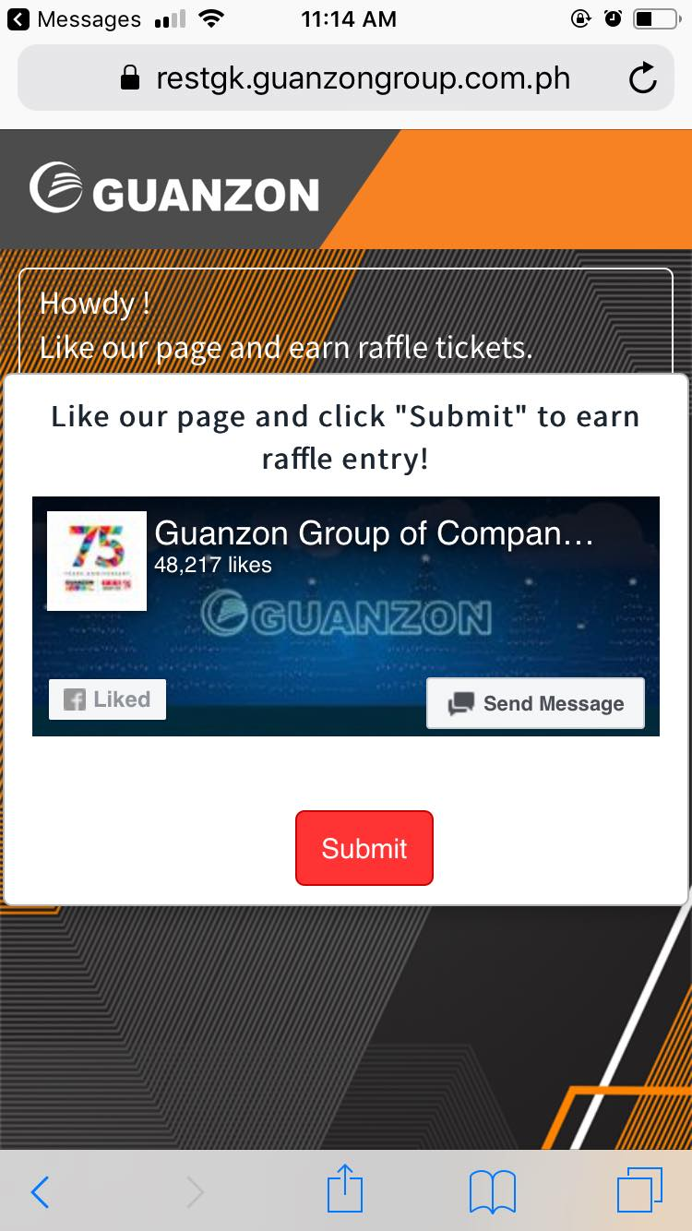

The customer can have 7 raffle entries for the link sent to him. He just have to LIKE our company affiliate pages.

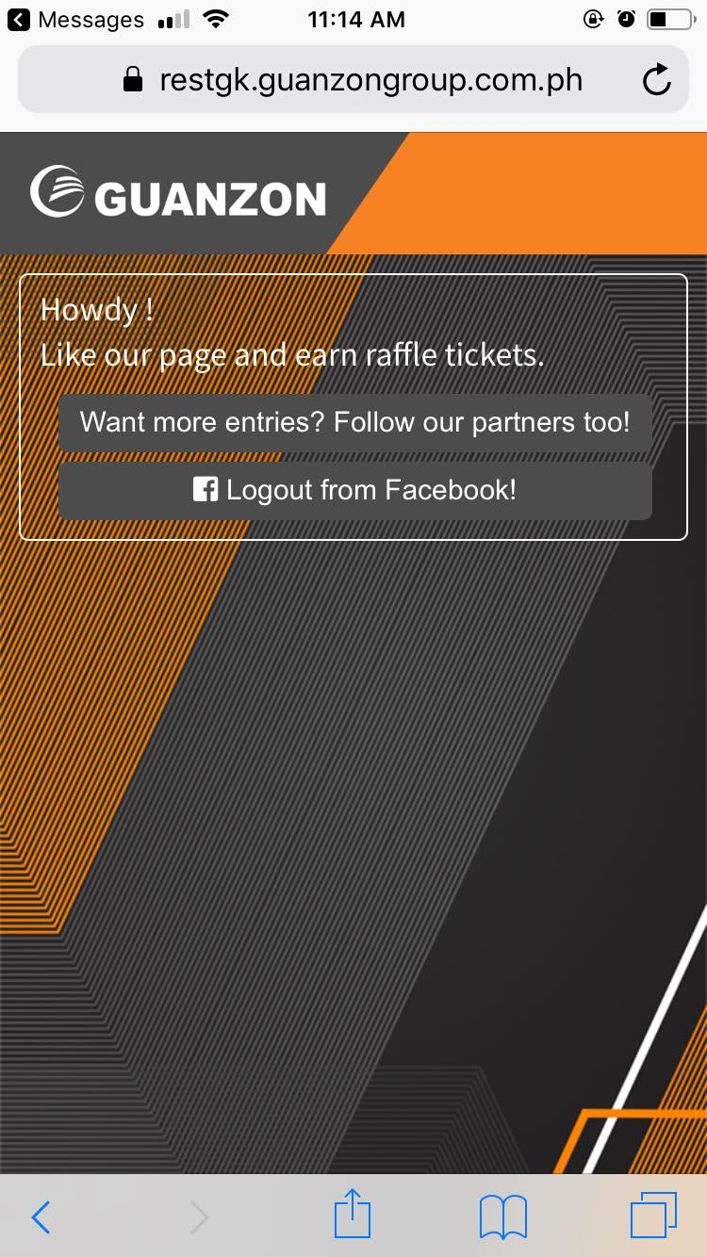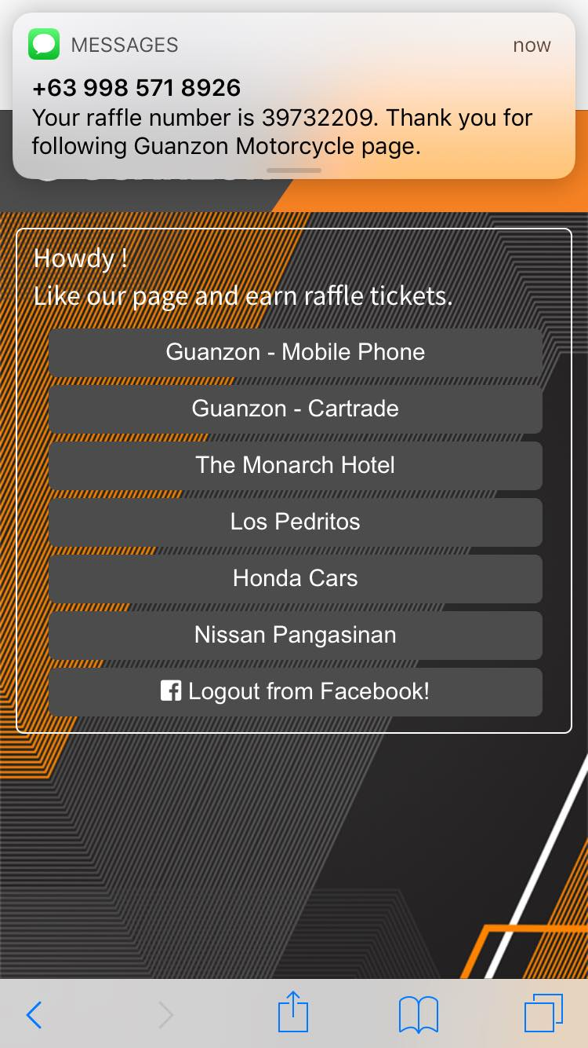
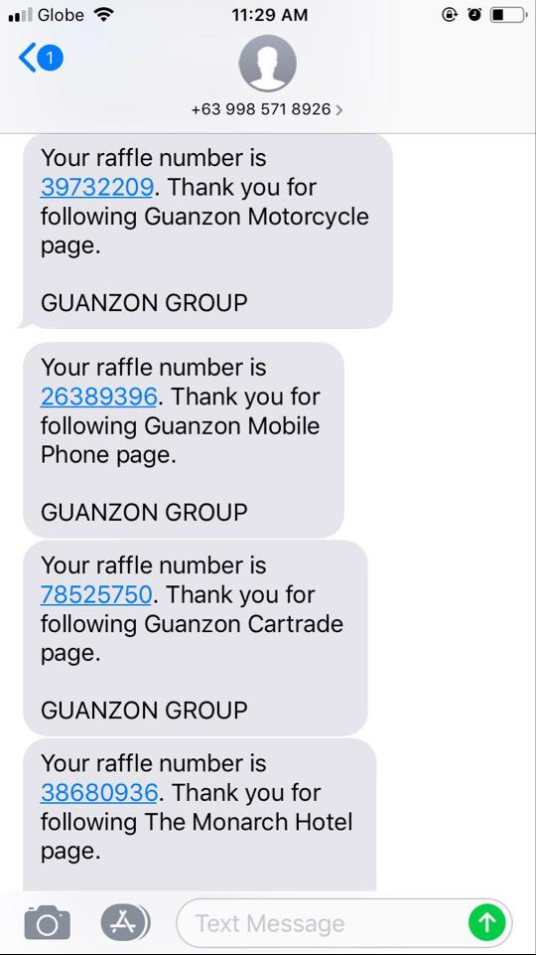
Confirmation Text
- Hiring Dashboard (Sabi ni sir marlon di na daw isama ta sa HDM naman)
- Collection Efficiency Monitoring thru DCP (Screenshot nalang ng gawa ni ate she)

Thanks!!!

